|  |
| --- |
| Ryerson University |
| Bank Marketing Strategy |
| Final Project - CIND119 Introduction to Big Data |

|  |
| --- |
| Patrick Little Manjola Chiappetta  4-20-2021 |

**Table of Contents**

Members 1

Summary 2

Tools 2

Workload Distribution 2

Exploratory Data Analysis 3

Predictive Modeling / Classification 9

Decision Tree 9

Naïve Bayes 12

Extreme Gradient Boosting 13

Initial Results 14

Feature Selection 15

Re-training on selected features 16

Decision Tree 16

Naive Bayes 16

XGBoost 16

Final Results 17

Conclusions and Recommendations 18

Appendix 19

Code 19

# Members

Patrick Litte, patrick.little@ryerson.ca

Manjola Chiappetta, m1chiappetta@ryerson.ca

# Summary

Our client, a Portuguese bank, is looking for improvements to their telemarketing strategy. The bank is marketing long-term deposit accounts such as bonds and savings account to a large variety of existing clients with a wide range of attributes. We were tasked with developing predictive models, by utilizing unsupervised learning techniques, to predict whether a client will subscribe to a term deposit. The predictive modelling will be built based on the bank’s experience in marketing the products. The predictive models would enable the bank to target their marketing activities more efficiently to clients with a greater likelihood of subscribing to a term deposit.

In this project, we compared two different predictive models, such as Decision Tree and Naïve Bayes, assessed their accuracy as well as their performance as measured by the Area Under the Receiver Operator Curve. Moreover, we contrasted the two predictive models against a more advanced Gradient Boosting model (XGBoost) to determine if a more advanced model would provide better results. In the chosen models, we will use the 10-fold cross validation method to assess the models’ predictive performance.

The accuracy of the different predictive models was remarkably similar. The decision tree provided 89.20% accuracy, Naïve Bayes 88.41%, and XGBoost 91.33%. Based on the accuracy level from each of the models, it is recommended that our client implement a Gradient Boosting model such as the model developed as part of this report to pre-screen caller lists.

## Tools

This project will leverage R for the exploratory data analysis, data preprocessing, predictive modeling, and model evaluation. We will use the tidymodels framework to implement our predictive modelling, and model evaluation, and we will use the DataExplorer package to aid in exploratory data analysis.

## Workload Distribution

|  |  |
| --- | --- |
| Member Name | List of Tasks Preformed |
| Patrick Little | EDA , Decision Trees, XGBoost,  Feature Selection, Project Report |
| Manjola Chiappetta | EDA, Naïve Bayes, Project Report |

# Exploratory Data Analysis

To better understand the data provided by our client, we will perform some initial investigations on the data to discover any patterns, spot anomalies, and to identify any outliers with the help of summary statistics and graphical representation. Some of the tasks that we will perform include:

1. Look at the attribute types in the dataset.
2. Find and missing values.
3. Examine the pairwise association between the variables.
4. Understand the total span of the data by finding measures such as max, min, mean and standard deviation of the attributes.
5. Determine any outlier values for the attributes under consideration.
6. Analyze the distribution of numeric attributes.

To begin the exploratory data analysis, we use the data explorer R package to generate an easy to consume overview of our dataset. Figure 1 illustrates the composition of the dataset and that there are a mix of discrete and continuous variables. Additionally, we can observe that there are no missing data observations contained within the dataset.

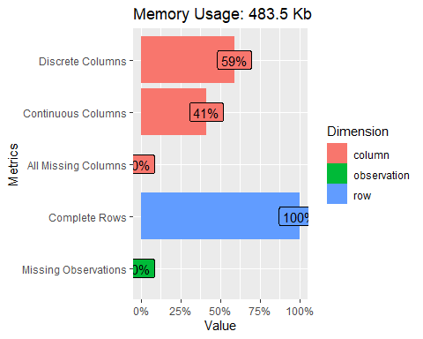

Figure 1 - *Dataset Attributes*

The dataset has 17 variables as indicated by the individual columns of dataset and it contains a combination of data types (Figure 2). The variables include data of type integer such as age, balance, day, duration, campaign, duration, pdays, and previous. Most of the variables (10) are of type character and include information on job, marital, education, default, housing, loan, contact, month, poutcome, and y (which is a binary class indicating whether clients have subscribed to a term deposit).

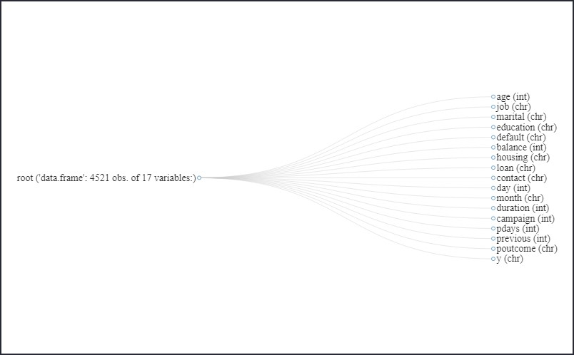

Figure 2 - Dataset structure network

We examine the values of the character variables to determine if character is the appropriate data type for each of the variables. If a variable of type character contains a limited number of possible values, then converting that variable to be of type factor will allow our predictive models to interpret that data without significant additional prepossessing. If the variables contain free form text without a controlled vocabulary for that variable, then likely additional natural language processing techniques such as stemming and lemmatization, along with other preprocessing or feature engineering may be required before those variables would offer significant predictive value to our models.

Table 1 illustrates each of the variables of type character with the universe of existing values for each variable, serving as a simple data dictionary. We can determine that this is a controlled vocabulary and there is not unstructured text in these fields. Since there is a controlled vocabulary being used with these variables, we will convert these variables to be of type factor.

Table 1 - Character Variables with all Existing Values

|  |  |  |  |  |  |  |  |  |
| --- | --- | --- | --- | --- | --- | --- | --- | --- |
| Job | Marital | Education | Default | Loan | Contact | Month | pOutcome | Y |
| admin. | divorced | primary | no | no | cellular | apr | failure | No |
| blue-collar | married | secondary | yes | yes | telephone | aug | other | Yes |
| entrepreneur | single | tertiary |  |  | unknown | dec | success |  |
| housemaid |  | unknown |  |  |  | feb | unknown |  |
| management |  |  |  |  |  | jan |  |  |
| retired |  |  |  |  |  | jul |  |  |
| self-employed |  |  |  |  |  | jun |  |  |
| services |  |  |  |  |  | mar |  |  |
| student |  |  |  |  |  | may |  |  |
| technician |  |  |  |  |  | nov |  |  |
| unemployed |  |  |  |  |  | oct |  |  |
| unknown |  |  |  |  |  | sep |  |  |

We can then examine the pairwise association between all the variables in the dataframe. For this analysis, we will use Spearman Correlation to measure the association between the numeric variables, Cramer’s V for the nominal factor data, and ANOVA to compare numeric data with factor data (Table 2).

Table 2 - Mixed Data Types Correlation/Association

|  |  |  |  |
| --- | --- | --- | --- |
| X | Y | Association | Type |
| previous | pdays | **0.9862904** | correlation |
| pdays | previous | **0.9862904** | correlation |
| poutcome | pdays | 0.8759717 | anova |
| pdays | poutcome | 0.8759717 | anova |
| poutcome | previous | 0.6850125 | anova |
| previous | poutcome | 0.6850125 | anova |
| month | contact | 0.5131000 | cramersV |
| contact | month | 0.5131000 | cramersV |
| job | age | 0.5061504 | anova |
| age | job | 0.5061504 | anova |
| month | housing | 0.4878000 | cramersV |
| housing | month | 0.4878000 | cramersV |
| education | job | 0.4551000 | cramersV |
| job | education | 0.4551000 | cramersV |
| month | day | 0.4490406 | Anova |
| day | month | 0.4490406 | Anova |

Looking at the top eight pairs of variables in the pairwise comparison sorted by the absolute value of the association measure, we can see that variables Previous and pDays appear to have a high measure of correlation. With a Spearman value of 0.986, we can state there is a highly monotonic relationship between the variables. In this metric, we are assessing if the variables move in the same direction, however this relation could have one of several non-linear relation types such as exponential, logistic, etc.

Examining the relationship between the numeric variables with a different metric, one can use the Pearson correlation to assess the linearity of the relationships. With an R value of 0.58, the relationship between the pDays and Previous variables is a moderate positive correlation. Since the R value is in a moderate range, there is still likely predictive value in including both variables in our models. More correlation information on the various variables is illustrated in Figure 3 below.

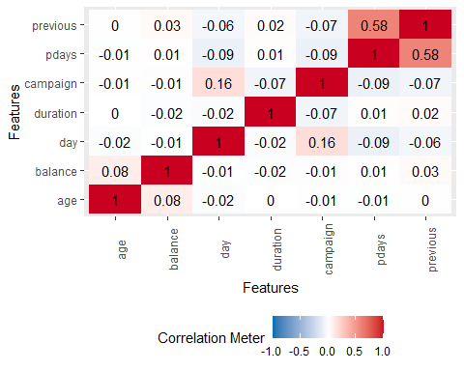

*Figure 3 – Correlation Matrix*

+

We can then identify if the dataset and more specifically the numeric variables contain outliers. Comparing the median, mean, min, and max values for our numeric variables, we can observe that many of our numeric variables each have max or min values that vary by an order of magnitude between the interquartile range (IQR) and the min/max value. This warrants furthur exploration into the outliers within the dataset.

*Table 3 – Median, mean, min and max values*

|  |  |  |  |  |  |
| --- | --- | --- | --- | --- | --- |
| age | Job | marital | education | default | balance |
| Min. :19.00 | management :969 | divorced: 528 | primary : 678 | no :4445 | Min. :-3313 |
| 1st Qu.:33.00 | blue-collar:946 | married :2797 | secondary:2306 | yes: 76 | 1st Qu.: 69 |
| Median :39.00 | technician :768 | single :1196 | tertiary :1350 |  | Median : 444 |
| Mean :41.17 | admin. :478 |  | unknown : 187 |  | Mean : 1423 |
| 3rd Qu.:49.00 | services :417 |  |  |  | 3rd Qu.: 1480 |
| Max. :87.00 | retired :230 |  |  |  | Max. :71188 |
|  | (Other) :713 |  |  |  |  |

|  |  |  |  |  |  |
| --- | --- | --- | --- | --- | --- |
| housing | loan | contact | day | month | duration |
| no :1962 | no :3830 | cellular :2896 | Min. : 1.00 | may :1398 | Min. : 4 |
| yes:2559 | yes: 691 | telephone: 301 | 1st Qu.: 9.00 | jul : 706 | 1st Qu.: 104 |
|  |  | unknown :1324 | Median :16.00 | aug : 633 | Median : 185 |
|  |  |  | Mean :15.92 | jun : 531 | Mean : 264 |
|  |  |  | 3rd Qu.:21.00 | nov : 389 | 3rd Qu.: 329 |
|  |  |  | Max. :31.00 | apr : 293 | Max. :3025 |
|  |  |  |  | (Other): 571 |  |

|  |  |  |  |  |
| --- | --- | --- | --- | --- |
| campaign | pdays | previous | poutcome | y |
| Min. : 1.000 | Min. : -1.00 | Min. : 0.0000 | failure: 490 | no :4000 |
| 1st Qu.: 1.000 | 1st Qu.: -1.00 | 1st Qu.: 0.0000 | other : 197 | yes: 521 |
| Median : 2.000 | Median : -1.00 | Median : 0.0000 | success: 129 |  |
| Mean : 2.794 | Mean : 39.77 | Mean : 0.5426 | unknown:3705 |  |
| 3rd Qu.: 3.000 | 3rd Qu.: -1.00 | 3rd Qu.: 0.0000 |  |  |
| Max. :50.000 | Max. :871.00 | Max. :25.0000 |  |  |

We can also use the above tables to provide a baseline success number for our client’s existing marketing effort. Based on the values of ‘y’ above, we can see that in 521 cases, customers subscribed to a term deposit product from the bank, and in 4,000 cases customers did not. This represents a conversion rate of 0.13025. One might deduce that a over 13% conversion rate on a marketing campaign is quite high, however using the analysis developed as part of this report, we feel we can increase our client’s conversion rate. Moreover, looking at a box plot of the numeric variables, we can get a sense for the extent of the distribution of outliers in each variable.

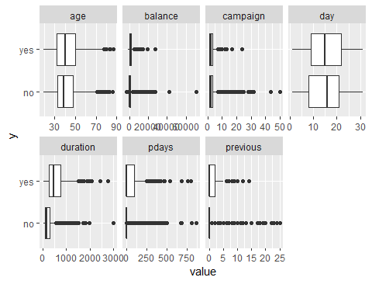

*Figure 4 – Boxplots*

Typically, we would remove outliers from the dataset, using the standard definition of 1.5*IQR. In the case of this dataset, using a standard outlier removal approach on all the predictor variables results in zero rows left in the dataset for analysis. Therefore, for the modeling instead of manually removing outliers from the data, we will apply a YeoJohnson transformation on the numeric variables. This should serve as an adequate method to both mitigate the effect of outliers, as well as contribute to normalizing the dataset. For the variable Day, although the data is encoded as a numeric variable, this represents more of a factor variable, therefore we will convert this variable to type factor such that it does not receive a YeoJohnson transform during the model preprocessing.

# Predictive Modeling / Classification

## Decision Tree

Decision Tree is one of the unsupervised learning algorithms that can be used to predict the class of the target variable(s) based on deduction from the training data. For the Decision Tree model, we used the ‘rpart’ package in the classification mode as this project is a binary classification problem. We used 10-fold cross validation to train the model. We also performed a YeoJohnson transformation on the numeric variables to help reduce the effect of outliers of the dataset and contribute to normalizing the data. This model requires we set three hyperparameters: cost complexity, tree depth, and the minimum number of data points within a node for it to be split further. Instead of manually setting these hyperparameters, we tuned these hyperparameters using a latin hypercube of size 60.

We can observe the structure of our decision tree below.

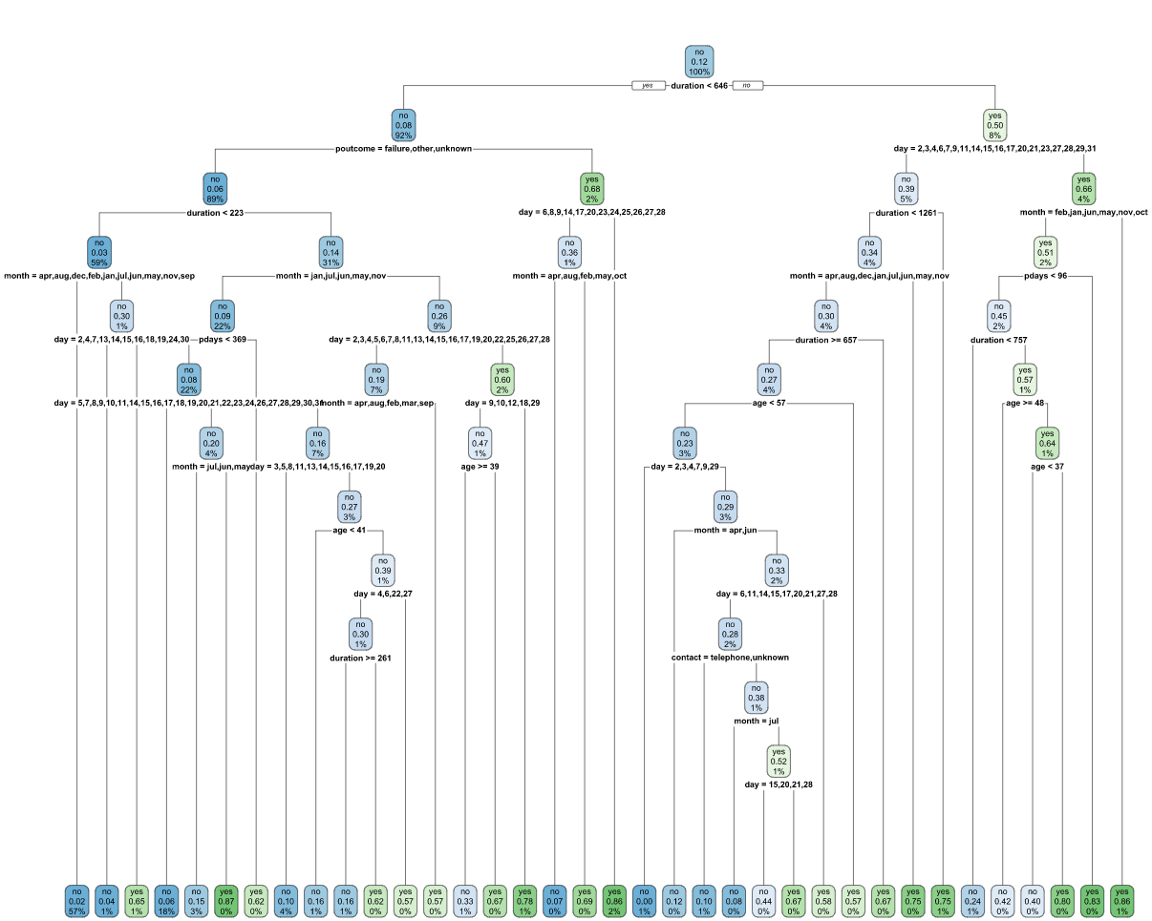

*Figure 5 – Decision Tree*

We can observe the area under the receiver operator curve for this initial model below:

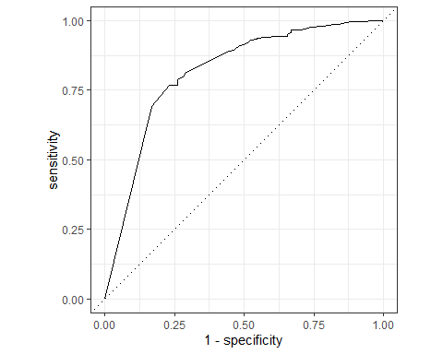

*Figure 6 – Decision Tree Accuracy and AUC*

The decision tree provides an initial model accuracy of 87.61% and AUC of 81.61%. This model produced the following confusion matrix.

|  |  |  |
| --- | --- | --- |
| Prediction / Truth | No | Yes |
| No | 945 | 85 |
| Yes | 55 | 45 |

## Naïve Bayes

The Naïve Bayes predictive model assumes the independence of the predictor attributes. For the Naïve Bayes model, we used the Naïve Bayes algorithm implemented by the ‘discrim’ package in R. There are several other Naïve Bayes implementations available within R such as KLaR, e1071, etc., however the discrim implementation of the model seems to integrate well within the tidymodels framework. For this model there are no hyperparameters that we need to explicitly set, therefore hyperparameter tuning was not used with this model. As with our decision tree model, we used 10-fold cross validation over a simple test-train split. Below we can observe the area under the receiver operator curve for this model’s results.

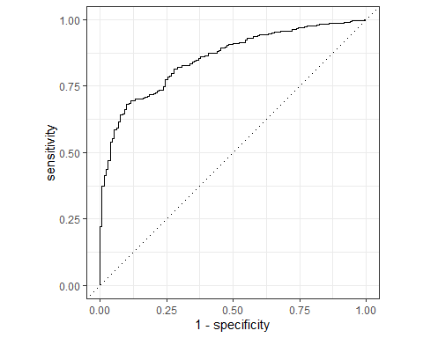

Figure 7 – Naïve Bayes Accuracy and AUC

The Naïve Bayes model produced an initial model accuracy of 88.05% and AUC of 85.33%. From this model the following a confusion matrix is generated.

|  |  |  |
| --- | --- | --- |
| Prediction / Truth | No | Yes |
| No | 957 | 92 |
| Yes | 43 | 38 |

## Extreme Gradient Boosting

For the Gradient Boosting model, we used the Extreme Gradient Boosting (XGBoost) algorithm implemented by the ‘xgboost’ package in R. In this model there are seven hyperparameters we need to set: mtry, trees, min_n, tree depth, learn rate, loss reduction, and sample size. For the number of trees, this is a computationally expensive hyperparameter to tune, therefore we will set this parameter manually at 2,000 trees, which should be a satisfactorily large number to satisfy the universe of potential outcomes based on the size of our dataset and number of predictors. As in the decision tree model, we tuned the remaining hyperparameters with a latin hypercube of size 60. For the XGBoost model, we also dummy encoded the data to attempt achieve an optimal result. Below we can observe the area under the receiver operator curve for our results with this model.

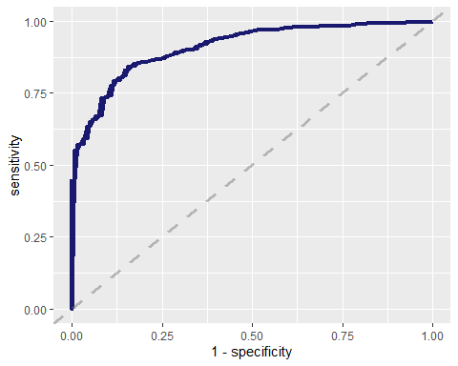

*Figure 8 – XGBoost Accuracy and AUC*

The Extreme Gradient Boosting produced an initial model accuracy of 91.33% and AUC of 91.22%. This model generated the following confusion matrix.

|  |  |  |
| --- | --- | --- |
| Prediction / Truth | No | Yes |
| No | 991 | 82 |
| Yes | 18 | 39 |

# Initial Results

Examining the initial results of the models, we can see that we were able to achieve good results with all predictors being included in the model. The results from the tuned Decision Tree and Naïve Bayes were outperformed by the XGBoost model. The results of the three models are presented on Table 4.

Table 4 – Initial predictive modeling results

|  |  |  |
| --- | --- | --- |
| Predictive Model | Accuracy | AUC |
| Decision Tree (tuned) | 87.61% | 81.61% |
| Naïve Bayes | 88.05% | 85.33% |
| XGBoost | 91.33% | 91.22% |

Since the source dataset for this project is relatively small, approximately 4,500 observations of 17 variables, we are achieving performant model training times even with 10-fold cross validation and hyperparameter tuning. The end-to-end model training and evaluation for the decision tree can complete in about two minutes running as a single threaded workflow.

The Naive Bayes model is even more performant, completing the end-to-end model training and evaluation workflow in about 4 seconds. Since we are not tuning hyperparameters in this model, having a fast training time is expected.

The XGBoost model is a significantly more complicated model, and therefore takes considerably more training time. In a multithreaded workflow with 4 dedicated CPU cores, the model takes about 25 minutes to train when using 2,000 trees and tuning our other hyperparameters with a latin hyper cube of size 60.

## Feature Selection

Feature selection reduces the number of variables, by removing irrelevant variables, to be used in the predictive modelling to improve accuracy. Using recursive feature selection, we can identify predictors that could be removed from the model, both to improve model training times and to potentially to reduce model overfitting. Based on a random forest algorithm, our recursive feature selection indicates that the best features to include in the model will be: Duration, Month, Day, pOutcome, pDay, age, Contact, and Previous. Additionally, we will ensure we preserve our target variable ‘y’ in the dataset. Using the above features, the recursive feature selection algorithm is indicating the model achieved an accuracy of 89.69%, training a random forest algorithm on the training data and evaluating the results on test data, with 10-fold cross validation.

Below we can observe a graph of our model accuracy, by number of predictor variables included in the model.

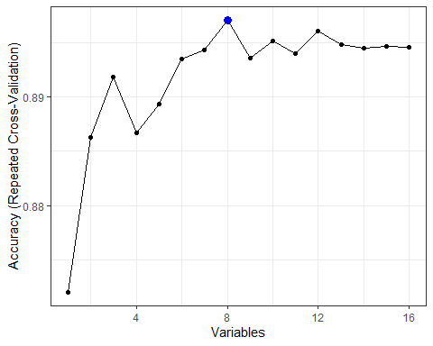

*Figure 9 – Recursive selection*

Using these selected predictor variables, we will repeat the same model training and evaluation steps using only the eight predictors indicated above.

# Re-training on selected features

## Decision Tree

Using the same model training approach described in the previous section, we re-trained and evaluated the model using only the predictors indicated by the recursive feature selection to achieve the best result. Using only Duration, Month, Day, pOutcome, pDay, Age, Contact, and Previous as predictors in the model, we were able to achieve a confusion matrix as follows:

|  |  |  |
| --- | --- | --- |
| Prediction / Truth | No | Yes |
| No | 944 | 66 |
| Yes | 56 | 64 |

The re-trained decision tree model generated final model accuracy of 89.2% and AUC of 84.0%.

## Naive Bayes

Again, using the same model training approach described in the previous section we re-trained and evaluated the model using only the predictors indicated by the recursive feature selection to achieve the best result. With our selected features, our final Naïve Bayes model was able to achieve a confusion matrix as follows:

|  |  |  |
| --- | --- | --- |
| Prediction / Truth | No | Yes |
| No | 963 | 94 |
| Yes | 37 | 36 |

The re-trained Naïve Bayes model produced a final model accuracy of 88.4% and AUC of 86.2%.

## XGBoost

Again, using the same model training approach described in the previous section we retrained and evaluated the model using only the predictors indicated by the recursive feature selection. With our selected features, our XGBoost model achieved a confusion matrix as follows:

|  |  |  |
| --- | --- | --- |
| Prediction / Truth | No | Yes |
| No | 994 | 89 |
| Yes | 15 | 32 |

The re-trained XGBoost model generated a final accuracy of 90.8% and AUC of 90.5%. A reduced model accuracy and AUC compared with the initial results.

# Final Results

After accounting for re-training, the model performance improved for both the Decision Tree and the Naive Bayes models. For the XGBoost model, limiting the number of predictors, inputted into the model, reduced performance. The model accuracy for the Decision Tree model increased to 89.20% with the selected features, versus 87.61% for all features selected. For the Naive Bayes model, accuracy in3creased to 88.4% compared with our previous result of 88.05%. With XGBoost, model accuracy decreased to 90.8% versus 91.33% with all variables feeding the model.

Table 5 – Comparison predictive modeling results

|  |  |  |  |
| --- | --- | --- | --- |
| Predictive Model | Initial Accuracy Results | Final Accuracy Results | Change Final vs Initial |
| Decision Tree | 87.61% | 89.20% | 1.59% |
| Naïve Bayes | 88.05% | 88.4% | 0.35% |
| XGBoost | 91.33% | 90.80% | -0.53% |

Additionally, by limiting the number of predictor variables we were able to train the models faster. With the subset of predictors, the Decision Tree model was able to complete the end-to-end training and evaluation workflow in about 75 seconds, verus about two minutes with the full dataset including all variables. The Naïve Bayes model also experienced a proportionally similar performance gain, completing the subset workflow in 3 seconds versus about 4 seconds with the full dataset. The XGBoost model also had improved training times, saving about 5 minutes of training time with the smaller dataset from the 25 minutes it took to train on the full dataset.

# Conclusions and Recommendations

We looked at different unsupervised learning models to assess the diagnostic performance based on our client’s data set. We took two steps in completing this project: data analysis/preparation and data modelling. We used exploratory data analysis to better understand the data and the variables. We then developing different models to assess the classifiers and to evaluate if further feature selection was required to improve the accuracy of the modelling.

Based on the various predictive modelling results, we can conclude that feature selection can be an important activity to improve model performance with machine learning models such as Naïve Bayes and Decision Trees. We were able to use several techniques to develop predictive models to predict if a client would subscribe to one of bank’s term deposit products with an overall accuracy of over 90%.

It is recommended that our client implement a Gradient Boosting model such as the model developed as part of this report to pre-screen caller lists. If our client were able to restrict their outgoing calls to clients that our model predicts would be likely to subscribe to a term deposit product, they would likely drastically improve their call conversion percentage, allowing them to get a much better ROI on their marketing spend. Additionally, reducing the volume of unwanted calls to clients not interested in term deposit products may improve their overall customer satisfaction.

# Appendix

This report was created as a R markdown document. In addition to the code behind the analysis in the section below, the R markdown document defining this report is available on GitHub at https://github.com/PatLittle/CIND119-group-project/blob/main/project.Rmd

## Code

knitr::opts_chunk$set(echo = TRUE)  
library(knitr)  
library(tidyverse)  
library(tidymodels)  
library(vip)  
library(rpart.plot)  
library(DataExplorer)  
library(tictoc)  
library(data.table)  
library(gtools)

```{r}

bank<-read.csv("https://raw.githubusercontent.com/PatLittle/CIND119-group-project/main/bank_marketing/bank.csv")  
plot_intro(bank)  
  
plot_str(bank, type="d", print_network = T, fontSize=25)  
  
  
job<-levels(as.factor(bank$job))  
marital<-levels(as.factor(bank$marital))  
education<-levels(as.factor(bank$education))  
default<-levels(as.factor(bank$default))  
housing<-levels(as.factor(bank$housing))  
loan<-levels(as.factor(bank$loan))  
contact<-levels(as.factor(bank$contact))  
month<-levels(as.factor(bank$month))  
poutcome<-levels(as.factor(bank$poutcome))  
y<-levels(as.factor(bank$y))  
  
na.pad <- function(x,len){  
 x[1:len]  
}  
  
makePaddedDataFrame <- function(l,...){  
 maxlen <- max(sapply(l,length))  
 data.frame(lapply(l,na.pad,len=maxlen),...)  
}  
  
a = job  
b = marital  
c = education  
d = default  
e = loan  
f = contact  
g = month  
h = poutcome  
j = y  
  
data_dict<-makePaddedDataFrame(list("Job"=a,"Marital"=b,"Education"=c,"Default"=d,"Loan"=e,"Contact"=f,"Month"=g,"pOutcome"=h,"y"=j))  
  
data_dict %>% na.replace("")  
options(knitr.kable.NA = '')  
kable(data_dict, caption="Character Variables with all Existing Values")  
bank_clean<- bank %>% mutate_if(is.character, factor)  
  
  
  
require(rcompanion)  
  
mixed_assoc = function(df, cor_method="spearman", adjust_cramersv_bias=TRUE){  
 df_comb = expand.grid(names(df), names(df), stringsAsFactors = F) %>% set_names("X1", "X2")  
  
 is_nominal = function(x) class(x) %in% c("factor", "character")  
   
 is_numeric <- function(x) { is.integer(x) || is_double(x)}  
  
 f = function(xName,yName) {  
 x = pull(df, xName)  
 y = pull(df, yName)  
  
 result = if(is_nominal(x) && is_nominal(y)){  
 cv = cramerV(as.character(x), as.character(y), bias.correct = adjust_cramersv_bias)  
 data.frame(xName, yName, assoc=cv, type="cramersV")  
  
 }else if(is_numeric(x) && is_numeric(y)){  
 correlation = cor(x, y, method=cor_method, use="complete.obs")  
 data.frame(xName, yName, assoc=correlation, type="correlation")  
  
 }else if(is_numeric(x) && is_nominal(y)){  
 r_squared = summary(lm(x ~ y))$r.squared  
 data.frame(xName, yName, assoc=sqrt(r_squared), type="anova")  
  
 }else if(is_nominal(x) && is_numeric(y)){  
 r_squared = summary(lm(y ~x))$r.squared  
 data.frame(xName, yName, assoc=sqrt(r_squared), type="anova")  
  
 }else {  
 warning(paste("unmatched column type combination: ", class(x), class(y)))  
 }  
  
   
 result %>% mutate(complete_obs_pairs=sum(!is.na(x) & !is.na(y)), complete_obs_ratio=complete_obs_pairs/length(x)) %>% rename(x=xName, y=yName)  
 }  
  
  
 map2_df(df_comb$X1, df_comb$X2, f)  
}  
  
cor_data<-mixed_assoc(bank_clean) %>% subset(assoc<0.99999) %>% arrange(desc(abs(assoc)))  
kable(cor_data[1:16,1:4],row.names = F, caption = "Mixed Data Types Correlation/Association")  
plot_correlation(bank_clean, type = "c", cor_args = list("method"="pearson"))  
  
kable(summary(bank_clean))  
  
  
plot_boxplot(bank_clean, by="y")  
  
age_out<-boxplot(bank_clean$age,plot=F)$out  
bal_out<-boxplot(bank_clean$balance,plot=F)$out  
campaign_out<-boxplot(bank_clean$campaign,plot=F)$out  
duration_out<-boxplot(bank_clean$duration,plot=F)$out  
pdays_out<-boxplot(bank_clean$pdays,plot=F)$out  
prev_out<-boxplot(bank_clean$previous,plot=F)$out  
  
bank_clean <- bank_clean[-which(bank_clean$age %in% age_out),]  
bank_clean <- bank_clean[-which(bank_clean$balance %in% bal_out),]  
bank_clean <- bank_clean[-which(bank_clean$campaign %in% campaign_out),]  
bank_clean <- bank_clean[-which(bank_clean$duration %in% duration_out),]  
bank_clean <- bank_clean[-which(bank_clean$pdays %in% pdays_out),]  
bank_clean <- bank_clean[-which(bank_clean$previous %in% prev_out),]  
  
head(bank_clean)  
  
  
bank_clean<- bank %>% mutate_if(is.character, factor)  
bank_clean$day<-as.factor(bank_clean$day)  
  
###Decision Tree  
  
  
tic()  
  
  
set.seed(888)  
bank_split <- initial_split(bank_clean, prop = 0.75,   
 strata = y)  
  
bank_training <- bank_split %>% training()  
bank_test <- bank_split %>% testing()  
bank_folds <- vfold_cv(bank_training, v = 10)  
  
  
  
bank_recipe <- recipe(y ~ ., data = bank_training) %>%  
 step_YeoJohnson(all_numeric(),-all_predictors())  
   
  
  
bank_clean_baked<-bank_recipe %>%   
 prep() %>%   
 bake(new_data = bank_training)  
  
tree_model <- decision_tree(cost_complexity = tune(),  
 tree_depth = tune(),  
 min_n = tune()) %>%   
 set_engine('rpart') %>%   
 set_mode('classification')  
  
tree_workflow <- workflow() %>%   
 add_model(tree_model) %>%   
 add_recipe(bank_recipe)  
  
tree_grid <- grid_latin_hypercube(cost_complexity(),  
 tree_depth(),  
 min_n(),   
 size = 60)  
  
set.seed(888)  
  
  
tree_tuning <- tree_workflow %>%   
 tune_grid(resamples = bank_folds,  
 grid = tree_grid)  
  
  
tree_tuning %>% show_best('roc_auc')  
  
best_tree <- tree_tuning %>%   
 select_best(metric = 'roc_auc')  
  
  
final_tree_workflow <- tree_workflow %>%   
 finalize_workflow(best_tree)  
  
  
tree_wf_fit <- final_tree_workflow %>%   
 fit(data = bank_training)  
  
tree_fit <- tree_wf_fit %>%   
 pull_workflow_fit()  
  
  
rpart.plot(tree_fit$fit, roundint = F)  
  
tree_last_fit <- final_tree_workflow %>%   
 last_fit(bank_split)  
  
tree_last_fit %>% collect_metrics()  
  
  
tree_last_fit %>% collect_predictions() %>%   
 roc_curve(truth = y, estimate = .pred_no) %>%   
 autoplot()  
  
tree_predictions <- tree_last_fit %>% collect_predictions()  
  
conf_mat(tree_predictions, truth = y, estimate = .pred_class)  
  
toc()  
  
  
tic()  
  
set.seed(888)  
nb_split <- initial_split(bank_clean, prop = 0.75,   
 strata = y)  
  
nb_training <- nb_split %>% training()  
nb_test <- nb_split %>% testing()  
nb_folds <- vfold_cv(nb_training, v = 10)  
  
nb_recipe <- recipe(y ~ ., data = nb_training) %>%  
 step_YeoJohnson(all_numeric(),-all_predictors())  
   
  
  
nb_wf <- workflow() %>%  
 add_recipe(nb_recipe)  
  
library(discrim)  
nb_spec <- naive_Bayes() %>%  
 set_mode("classification") %>%  
 set_engine("naivebayes")  
  
nb_spec  
  
nb_fit <- nb_wf %>%  
 add_model(nb_spec) %>%  
 fit(data = nb_training)  
  
nb_wf_final <- workflow() %>%  
 add_recipe(nb_recipe) %>%  
 add_model(nb_spec)  
  
nb_rs <- fit_resamples(  
 nb_wf_final,  
 nb_folds,  
 control = control_resamples(save_pred = TRUE)  
)  
  
  
nb_last_fit <- nb_wf_final %>%   
 last_fit(nb_split)  
  
nb_last_fit %>% collect_metrics()  
  
nb_last_fit %>% collect_predictions() %>%   
 roc_curve(truth = y, estimate = .pred_no) %>%   
 autoplot()  
  
nb_predictions <- nb_last_fit %>% collect_predictions()  
conf_mat(nb_predictions, truth = y, estimate = .pred_class)  
  
toc()  
  
tic()  
  
bank_clean<-as.data.table(bank_clean)  
  
set.seed(888)  
xg_split<- initial_split(bank_clean)  
xg_train<-training(xg_split)  
xg_test<-testing(xg_split)  
  
set.seed(888)  
xg_folds<-vfold_cv(xg_train,v=10)  
  
xgb_spec <- boost_tree(  
 trees = 2000,   
 tree_depth = tune(), min_n = tune(),   
 loss_reduction = tune(),   
 sample_size = tune(), mtry = tune(),   
 learn_rate = tune()   
) %>%   
 set_engine("xgboost") %>%   
 set_mode("classification")  
  
xgb_spec  
  
xgb_grid <- grid_latin_hypercube(  
 tree_depth(),  
 min_n(),  
 loss_reduction(),  
 sample_size = sample_prop(),  
 finalize(mtry(), xg_train),  
 learn_rate(),  
 size = 60  
)  
  
xgb_grid  
  
xgb_recipe <- recipe(y ~ ., data = xg_train) %>%  
 step_dummy(all_nominal(), -all_outcomes())  
   
  
  
  
xgb_recipe %>%  
 prep() %>%  
 bake(new_data = xg_train)   
  
  
  
xgb_wf <- workflow() %>%  
 add_model(xgb_spec) %>%  
 add_recipe(xgb_recipe)  
  
  
  
  
library(doParallel)  
cores<-detectCores()  
cl<- makeCluster(cores[1]-4)  
registerDoParallel(cl)  
  
  
set.seed(888)  
xgb_res <- tune_grid(  
 xgb_wf,  
 resamples = xg_folds,  
 grid = xgb_grid,  
 control = control_grid(save_pred = TRUE))  
  
best_auc <- select_best(xgb_res, "roc_auc")  
  
  
  
final_xgb <- finalize_workflow(  
 xgb_wf,  
 best_auc  
)  
  
  
final_res <- last_fit(final_xgb, xg_split)  
collect_metrics(final_res)  
  
  
final_res %>%  
 collect_predictions() %>%  
 roc_curve(y, .pred_no) %>%  
 ggplot(aes(x = 1 - specificity, y = sensitivity)) +  
 geom_line(size = 1.5, color = "midnightblue") +  
 geom_abline(  
 lty = 2, alpha = 0.5,  
 color = "gray50",  
 size = 1.2  
 )  
  
  
final_res %>%  
 collect_predictions() %>%   
 conf_mat(truth = y, estimate = .pred_class)  
  
library(vip)  
final_xgb %>%  
 fit(data = xg_train) %>%  
 pull_workflow_fit() %>%  
 vip(geom = "col")  
  
toc()  
tic()  
library("caret")  
control <- rfeControl(functions = rfFuncs, # random forest  
 method = "repeatedcv", # repeated cv  
 repeats = 5, # number of repeats  
 number = 10) # number of folds  
  
# Features  
x <- bank_clean %>%  
 select(-y) %>%  
 as.data.frame()  
  
# Target variable  
y <- bank_clean$y  
  
# Training: 80%; Test: 20%  
set.seed(888)  
inTrain <- createDataPartition(y, p = .80, list = FALSE)[,1]  
  
x_train <- x[ inTrain, ]  
x_test <- x[-inTrain, ]  
  
y_train <- y[ inTrain]  
y_test <- y[-inTrain]  
  
result_rfe1 <- rfe(x = x_train,   
 y = y_train,   
 sizes = c(1:16),  
 rfeControl = control)  
  
# Print the results  
result_rfe1  
  
# Print the selected features  
predictors(result_rfe1)  
  
# Print the results visually  
ggplot(data = result_rfe1, metric = "Accuracy") + theme_bw()  
  
toc()  
###subsetting our selected features  
bank_selected<-bank_clean[,c("duration","month","day","poutcome","pdays","age","contact","previous","y")]  
  
###Decision Tree  
  
  
  
tic()  
  
  
  
set.seed(888)  
bank_split <- initial_split(bank_selected, prop = 0.75,   
 strata = y)  
  
bank_training <- bank_split %>% training()  
bank_test <- bank_split %>% testing()  
bank_folds <- vfold_cv(bank_training, v = 10)  
  
  
  
bank_recipe <- recipe(y ~ ., data = bank_training) %>%  
 step_YeoJohnson(all_numeric(),-all_predictors())  
   
  
  
bank_clean_baked<-bank_recipe %>%   
 prep() %>%   
 bake(new_data = bank_training)  
  
tree_model <- decision_tree(cost_complexity = tune(),  
 tree_depth = tune(),  
 min_n = tune()) %>%   
 set_engine('rpart') %>%   
 set_mode('classification')  
  
tree_workflow <- workflow() %>%   
 add_model(tree_model) %>%   
 add_recipe(bank_recipe)  
  
tree_grid <- grid_latin_hypercube(cost_complexity(),  
 tree_depth(),  
 min_n(),   
 size = 60)  
  
set.seed(888)  
  
  
tree_tuning <- tree_workflow %>%   
 tune_grid(resamples = bank_folds,  
 grid = tree_grid)  
  
  
tree_tuning %>% show_best('roc_auc')  
  
best_tree <- tree_tuning %>%   
 select_best(metric = 'roc_auc')  
  
  
final_tree_workflow <- tree_workflow %>%   
 finalize_workflow(best_tree)  
  
  
tree_wf_fit <- final_tree_workflow %>%   
 fit(data = bank_training)  
  
tree_fit <- tree_wf_fit %>%   
 pull_workflow_fit()  
  
  
rpart.plot(tree_fit$fit, roundint = F)  
  
tree_last_fit <- final_tree_workflow %>%   
 last_fit(bank_split)  
  
tree_last_fit %>% collect_metrics()  
  
  
tree_last_fit %>% collect_predictions() %>%   
 roc_curve(truth = y, estimate = .pred_no) %>%   
 autoplot()  
  
tree_predictions <- tree_last_fit %>% collect_predictions()  
  
conf_mat(tree_predictions, truth = y, estimate = .pred_class)  
  
toc()  
  
  
tic()  
  
set.seed(888)  
nb_split <- initial_split(bank_selected, prop = 0.75,   
 strata = y)  
  
nb_training <- nb_split %>% training()  
nb_test <- nb_split %>% testing()  
nb_folds <- vfold_cv(nb_training, v = 10)  
  
nb_recipe <- recipe(y ~ ., data = nb_training) %>%  
 step_YeoJohnson(all_numeric(),-all_predictors())  
   
  
  
nb_wf <- workflow() %>%  
 add_recipe(nb_recipe)  
  
library(discrim)  
nb_spec <- naive_Bayes() %>%  
 set_mode("classification") %>%  
 set_engine("naivebayes")  
  
  
  
nb_fit <- nb_wf %>%  
 add_model(nb_spec) %>%  
 fit(data = nb_training)  
  
nb_wf_final <- workflow() %>%  
 add_recipe(nb_recipe) %>%  
 add_model(nb_spec)  
  
nb_rs <- fit_resamples(  
 nb_wf_final,  
 nb_folds,  
 control = control_resamples(save_pred = TRUE)  
)  
  
  
nb_last_fit <- nb_wf_final %>%   
 last_fit(nb_split)  
  
nb_last_fit %>% collect_metrics()  
  
nb_last_fit %>% collect_predictions() %>%   
 roc_curve(truth = y, estimate = .pred_no) %>%   
 autoplot()  
  
nb_predictions <- nb_last_fit %>% collect_predictions()  
conf_mat(nb_predictions, truth = y, estimate = .pred_class)  
  
toc()  
  
tic()  
  
bank_selected<-as.data.table(bank_selected)  
  
set.seed(888)  
xg_split<- initial_split(bank_selected)  
xg_train<-training(xg_split)  
xg_test<-testing(xg_split)  
  
set.seed(888)  
xg_folds<-vfold_cv(xg_train,v=10)  
  
xgb_spec <- boost_tree(  
 trees = 2000,   
 tree_depth = tune(), min_n = tune(),   
 loss_reduction = tune(),   
 sample_size = tune(), mtry = tune(),   
 learn_rate = tune()   
) %>%   
 set_engine("xgboost") %>%   
 set_mode("classification")  
  
  
  
xgb_grid <- grid_latin_hypercube(  
 tree_depth(),  
 min_n(),  
 loss_reduction(),  
 sample_size = sample_prop(),  
 finalize(mtry(), xg_train),  
 learn_rate(),  
 size = 60  
)  
  
  
  
xgb_recipe <- recipe(y ~ ., data = xg_train) %>%  
 step_dummy(all_nominal(), -all_outcomes())  
   
  
  
  
xgb_recipe %>%  
 prep() %>%  
 bake(new_data = xg_train)   
  
  
  
xgb_wf <- workflow() %>%  
 add_model(xgb_spec) %>%  
 add_recipe(xgb_recipe)  
  
  
  
  
library(doParallel)  
cores<-detectCores()  
cl<- makeCluster(cores[1]-4)  
registerDoParallel(cl)  
  
  
set.seed(888)  
xgb_res <- tune_grid(  
 xgb_wf,  
 resamples = xg_folds,  
 grid = xgb_grid,  
 control = control_grid(save_pred = TRUE))  
  
best_auc <- select_best(xgb_res, "roc_auc")  
  
  
  
final_xgb <- finalize_workflow(  
 xgb_wf,  
 best_auc  
)  
  
  
final_res <- last_fit(final_xgb, xg_split)  
collect_metrics(final_res)  
  
  
final_res %>%  
 collect_predictions() %>%  
 roc_curve(y, .pred_no) %>%  
 ggplot(aes(x = 1 - specificity, y = sensitivity)) +  
 geom_line(size = 1.5, color = "midnightblue") +  
 geom_abline(  
 lty = 2, alpha = 0.5,  
 color = "gray50",  
 size = 1.2  
 )  
  
final_res %>%  
 collect_predictions() %>%   
 conf_mat(truth = y, estimate = .pred_class)  
  
toc()  
```

```{r ref.label = knitr::all_labels(), echo = TRUE, eval = FALSE}

# this R markdown chunk generates a code appendix

```